

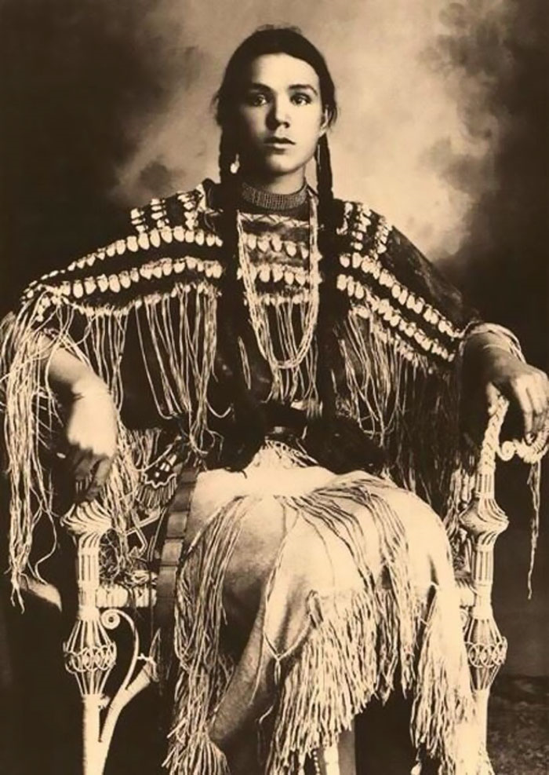

*Gertrude Three Finger, Cheyenne, 1869-1904, by William E. Irwin*

goes

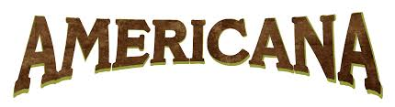

The ‘Mason-Dixon Line’

Sailing to Philadelphia *(Mark Knopfler/James Taylor)*

American Civil War - The War between the States

The Night They Drove Old Dixie Down *(Joan Baez)*

The ‘Dust Bowl’ - The Dirty Thirties

Ballad of Hollis Brown *(Bob Dylan)*

Vietnam War

Ohio *(Neil Young)*

The ‘Rust Belt‘

The L&N *(Michelle Shocked)*

Land of the Free

Chimes of Freedom *(Bruce Springsteen)*

The Mexican Border

Across the Wire *(Calexico)*

American Suburbs

City with no Children *(Arcade Fire)*

British Roots

God Save the Queen *(Neil Young)*

The Blues

Blind Willy McTell *(Bob Dylan)*

**Sailing to Philadelphia** *(Mark Knopfler/James Taylor)*

I am Jeremiah Dixon  
I am a Geordie boy  
A glass of wine with you, sir  
And the ladies I'll enjoy  
All Durham and Northumberland  
Is measured up by my own hand  
It was my fate from birth  
To make my mark upon the earth

He calls me Charlie Mason  
A stargazer am I  
It seems that I was born  
To chart the evening sky  
They'd cut me out for baking bread  
But I had other dreams instead  
This baker's boy from the west country  
Would join the Royal Society

We are sailing to Philadelphia  
A world away from the coaly Tyne  
Sailing to Philadelphia  
To draw the line  
The Mason-Dixon Line

Now you're a good surveyor, Dixon  
 But I swear you'll make me mad  
 The West will kill us both  
 You gullible Geordie lad  
 You talk of liberty  
 How can America be free  
 A Geordie and a baker's boy

In the forests of the Iroquois

Now hold your head up, Mason  
 See America lies there  
 The morning tide has raised  
 The capes of Delaware  
 Come up and feel the sun  
 A new morning has begun  
 Another day will make it clear  
 Why your stars should guide us here  
  
 We are sailing to Philadelphia  
 A world away from the coaly Tyne  
 Sailing to Philadelphia   
 To draw the line  
 The Mason-Dixon Line

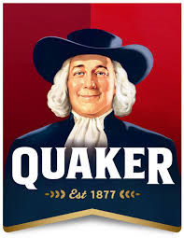 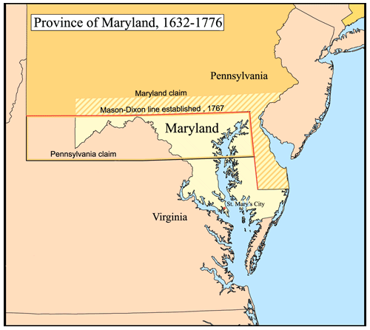 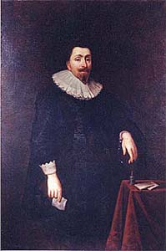

*William Penn George Calvert*

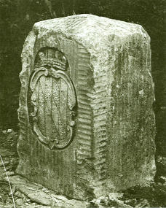 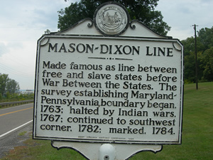

*Mason-Dixon marker*

**The Night They Drove Old Dixie Down** *(Joan Baez)*

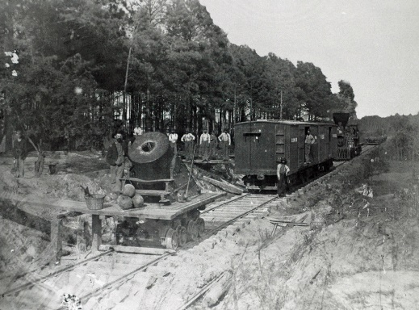 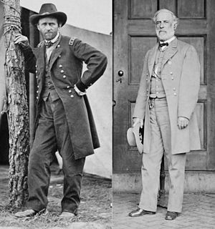

*The Danville train Ulysses Grant Robert E. Lee*

Virgil Caine is my name and I drove on the Danville train

'til so much cavalry came and tore up the tracks again

In the winter of '65, we were hungry, just barely alive

I took the train to Richmond that fell

It was a time I remember, oh, so well

The night they drove old Dixie down

And all the bells were ringin'

The night they drove old Dixie down

And all the people were singin'

They went, "Na, na, na, na, na, na, .... "

Back with my wife in Tennessee

And one day she said to me,

"Virgil, Quick! Come see!

There goes Robert E. Lee."

Now I don't mind, I'm chopping wood

And I don't care if the money's no good

Just take what you need and leave the rest

But they should never have taken the very best

The night they drove old Dixie down

And all the bells were ringin'

The night they drove old Dixie down

And all the people were singin'

They went, "Na, na, na, na, na, na, ..... "

Like my father before me, I'm a working man

And like my brother before me, I took a rebel stand

Oh, he was just 18, proud and brave

But a yankee laid him in his grave

I swear by the blood below my feet

You can't raise a Cane back up when he's in defeat

The night they drove old Dixie down

And all the bells were ringin'

The night they drove old Dixie down

And all the people were singin'

They went, "Na, na, na, na, na, na, ..... "

*J. Robie Robertson - The Band, 1970 Canaan Music / Joan Baez - Hits/Greatest & Others, 1973 Vanguard / Bob Dylan - Before The Flood, 1974 & 1990 Sony*

**Ballad of Hollis Brown** *(Bob Dylan)*

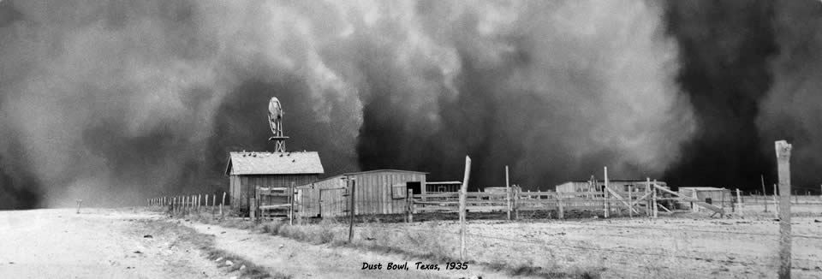

Hollis Brown  
He lived on the outside of town  
Hollis Brown  
He lived on the outside of town  
With his wife and five children  
And his cabin fallin’ down  
  
You looked for work and money  
And you walked a rugged mile  
You looked for work and money  
And you walked a rugged mile  
Your children are so hungry  
That they don’t know how to smile  
  
Your baby’s eyes look crazy  
They’re a-tuggin’ at your sleeve  
Your baby’s eyes look crazy  
They’re a-tuggin’ at your sleeve  
You walk the floor and wonder why  
With every breath you breathe  
  
The rats have got your flour  
Bad blood it got your mare  
The rats have got your flour  
Bad blood it got your mare  
If there’s anyone that knows  
Is there anyone that cares?  
  
You prayed to the Lord above  
Oh please send you a friend  
You prayed to the Lord above  
Oh please send you a friend  
Your empty pockets tell yuh  
That you ain’t a-got no friend  
  
Your babies are crying louder  
It’s pounding on your brain  
Your babies are crying louder now  
It’s pounding on your brain  
Your wife’s screams are stabbin’ you  
Like the dirty drivin’ rain

Your grass it is turning black  
There’s no water in your well  
Your grass is turning black  
There’s no water in your well  
You spent your last lone dollar  
On seven shotgun shells  
  
Way out in the wilderness  
A cold coyote calls  
Way out in the wilderness  
A cold coyote calls  
Your eyes fix on the shotgun  
That’s hangin’ on the wall

Your brain is a-bleedin’  
And your legs can’t seem to stand  
Your brain is a-bleedin’  
And your legs can’t seem to stand  
Your eyes fix on the shotgun  
That you’re holdin’ in your hand  
  
There’s seven breezes a-blowin’  
All around the cabin door  
There’s seven breezes a-blowin’  
All around the cabin door  
Seven shots ring out  
Like the ocean’s pounding roar  
  
There’s seven people dead  
On a South Dakota farm  
There’s seven people dead  
On a South Dakota farm  
Somewhere in the distance  
There’s seven new people born

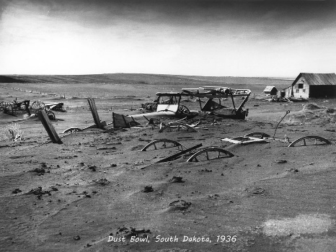

**Ohio** *(Neil Young)*

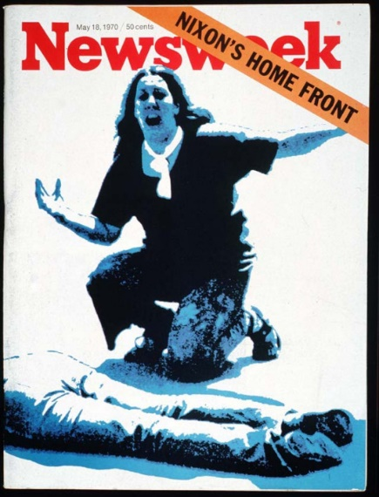

Tin soldiers and Nixon coming,

We’re finally on our own.

This summer I hear the drumming,

Four dead in Ohio.

Gotta get down to it

Soldiers are cutting us down

Should I have been done long ago.

What if you knew her

And found her dead on the ground

How can you run when you know?

Gotta get down to it

Soldiers are cutting us down

Should I have been done long ago.

What if you knew her

And found her dead on the ground

How can you run when you know?

Tin soldiers and Nixon coming,

We’re finally on our own.

This summer I hear the drumming,

Four dead in Ohio.

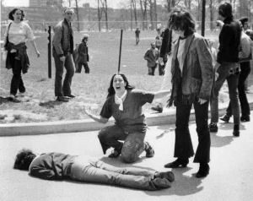

*Kent State May 4,1970 massacre: Pulitzer Price winning photograph of*[*Mary Ann Vecchio*](https://en.wikipedia.org/wiki/Mary_Ann_Vecchio)*, a 14-year-old runaway, kneeling over the body of*[*Jeffrey Miller*](https://en.wikipedia.org/wiki/Jeffrey_Miller)*minutes after he was fatally shot by the*[*Ohio National Guard*](https://en.wikipedia.org/wiki/Ohio_Army_National_Guard)

**The L&N** *(Michelle Shocked)*

*(writer: Jean Ritchie)*

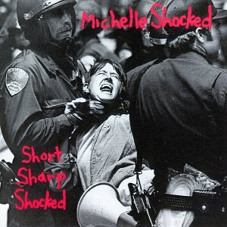 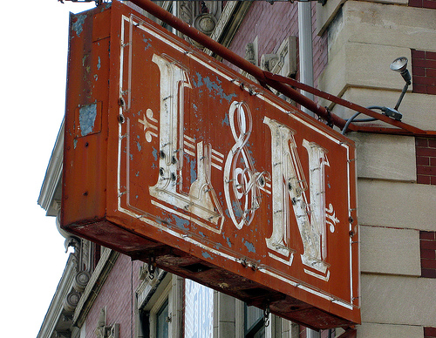 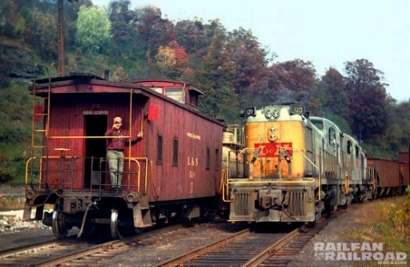

*The Louisville-Nashville Train*

When I was a curly headed baby  
My daddy set me down on his knee  
Saying, "Son, you go to school  
You learn your letters  
Now, don't you be no dusty miner, boy, like me"  
  
Oh, I was born and raised at the mouth of the Hazzard Holler  
Where the coal cars rolled and rumbled past my door  
Now they stand in a rusty row of all empties  
Because the L&N don't stop here anymore  
  
I used to think my daddy was a black man  
With script enough to buy the company store  
But now he goes to town with empty pockets  
And, Lord, his face is white  
As the February snow  
  
I was born and raised at the mouth of the Hazzard Holler  
Where the coal cars rolled and rumbled past my door  
But now they stand in a rusty row of all empties  
Because the L&N don't stop here anymore  
  
Never thought I'd live to learn to love the coal dust  
Never thought I'd pray to hear those temples roar  
But, God, I wish the grass would turn to money  
And then them greenbacks  
Would fill my pockets once more  
  
I was born and raised at the mouth of the Hazzard Holler  
Where the coal cars rolled and rumbled past my door  
But now they stand in a rusty row of all empties  
Because the L&N don't stop here anymore  
  
Last night I dreamed I went down to the office  
To get my payday like I’ve done before  
But them old kudzu vines, they was covering over the doorway  
And there was leaves and grass  
Growing right up to the floor  
  
I was born and raised at the mouth of the Hazzard Holler  
Where the coal cars rolled and rumbled past my door  
But now they stand in a rusty row of all empties  
Because the L&N don't stop here anymore  
Because the L&N don't stop here anymore  
Aw, the L&N don't stop here anymore

**Chimes of Freedom** *(Bob Dylan) (Bruce Springsteen)*

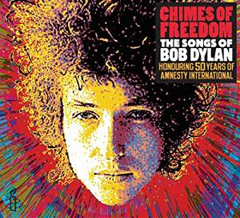

Far between sundown's finish an' midnight's broken toll  
We ducked inside the doorway, thunder crashing  
As majestic bells of bolts struck shadows in the sounds  
Seeming to be the chimes of freedom flashing  
Flashing for the warriors whose strength is not to fight  
Flashing for the refugees on the unarmed road of flight  
An' for each an' ev'ry underdog soldier in the night  
An' we gazed upon the chimes of freedom flashing  
  
Through the city's melted furnace, unexpectedly we watched  
With faces hidden as the walls were tightening  
As the echo of the wedding bells before the blowin' rain  
Dissolved into the bells of the lightning  
Tolling for the rebel, tolling for the rake  
Tolling for the luckless, the abandoned an' forsakened  
Tolling for the outcast, burnin' constantly at stake  
An' we gazed upon the chimes of freedom flashing  
  
*Through the mad mystic hammering of the wild ripping hail  
The sky cracked its poems in naked wonder  
That the clinging of the church bells blew far into the breeze  
Leaving only bells of lightning and its thunder  
Striking for the gentle, striking for the kind  
Striking for the guardians and protectors of the mind  
An' the poet and the painter far behind his rightful time  
An' we gazed upon the chimes of freedom flashing  
  
In the wild cathedral evening the rain unraveled tales  
For the disrobed faceless forms of no position  
Tolling for the tongues with no place to bring their thoughts  
All down in taken-for-granted situations  
Tolling for the deaf an' blind, tolling for the mute  
For the mistreated, mateless mother, the mistitled prostitute  
For the misdemeanor outlaw, chained an' cheated by pursuit  
An' we gazed upon the chimes of freedom flashing*  
Even though a cloud's white curtain in a far-off corner flash  
An' the hypnotic splattered mist was slowly lifting  
Electric light still struck like arrows, fired but for the ones  
Condemned to drift or else be kept from drifting  
Tolling for the searching ones, on their speechless, seeking trail  
For the lonesome-hearted lovers with too personal a tale  
An' for each unharmful, gentle soul misplaced inside a jail  
An' we gazed upon the chimes of freedom flashing  
  
Starry-eyed an' laughing as I recall when we were caught  
Trapped by no track of hours for they hanged suspended  
As we listened one last time an' we watched with one last look  
Spellbound an' swallowed 'til the tolling ended  
Tolling for the aching ones whose wounds cannot be nursed  
For the countless confused, accused, misused, strung-out ones an' worse  
An' for every hung-up person in the whole wide universe  
An' we gazed upon the chimes of freedom flashing

**Across the Wire** *(Calexico)*

Alberto hits his brother on the  
Back of the head, looks to the north  
As he starts to get up

His brothers still sleepy

Grumbles "It's not light yet,"  
"If you want a new life, what's  
A few minutes wait?"

Darkness on the road and over the land

Into the laws and out of the hands  
From those with so much  
And no show of heart  
You'd think it'd be crazy

To ask for a small part

Spotted an eagle in the middle of a lake  
Resting on cactus, feasting on snakes  
But the waters recede as the dump closes in,

Revealing a whole lake of sleeping children



Poison in the stream that flows to the sea  
Out on the waves that crash within reach

Of those with so much and so little to fear  
You'd think it'd be crazy  
To be so far away yet so near

Some say a new day will shine here  
Over these catastrophes and horrors  
Of misfortune, all across the wire  
Alberto why hermano on the coyote's trail

And dodging the shadows of the border patrol  
Out in the wastelands wandering for days  
The future looks bleak  
With no sign of change

Darkness in the eye and down in the soul  
All across the wire with those in control  
Holding so much with no show of heart  
You think it'd be crazy  
To watch it all fall apart  
Watch it all fall apart

**City with no Children** *(Arcade Fire)*

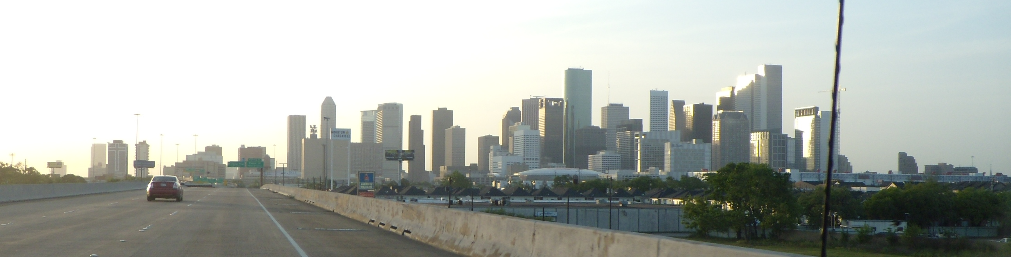

*Houston*

The summer that I broke my arm  
I waited for your letter  
I have no feeling for you now  
Now that I know you better

I wish that I could have loved you then  
Before our age was through  
And before a world war does with us  
Whatever it will do

Dreamt I drove home to Houston  
On a highway that was underground  
There was no light that we could see  
As we listened to the sound of the engine failing

I feel like I've been living in  
A city with no children in it  
A garden left for ruin by a millionaire inside  
Of a private prison

You never trust a millionaire  
Quoting the sermon on the mount  
I used to think I was not like them  
But I'm beginning to have my doubts  
My doubts about it

When you're hiding underground  
The rain can't get you wet  
Do you think your righteousness  
Can pay the interest on your debt?  
I have my doubts about it

I feel like I've been living in  
A city with no children in it  
A garden left for ruin by a millionaire inside  
Of a private prison

I feel like I've been living in  
A city with no children in it  
A garden left for ruin by and by  
As I hide inside  
Of my private prison

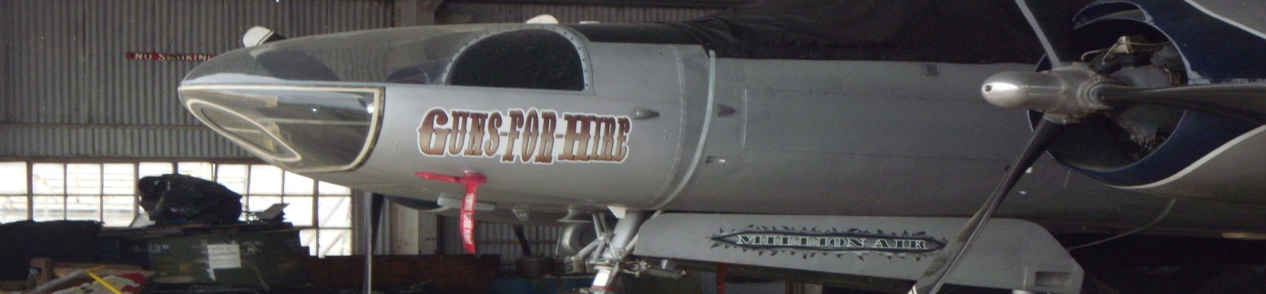

Million Air

**God Save the Queen** *(Neil Young & Crazy Horse)*

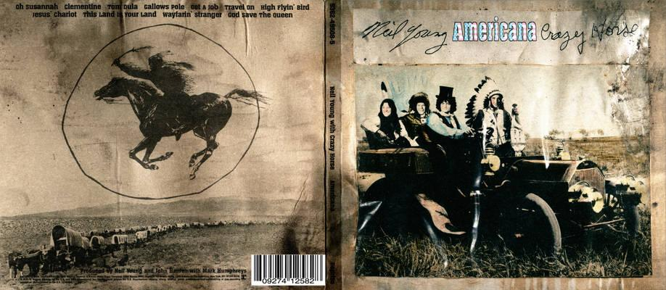

*Original Neil Young version*

*God save our gracious Queen* God save our gracious Queen  
*Long live our noble Queen* Long live our noble Queen  
*God save the Queen* God save the Queen  
*Send her victorious* Send her victorious  
*Happy and glorious* Happy and glorious  
*Long to reign over us* Long to reign over us  
*God save the Queen* God save the Queen

(*Chorus) Long may she reign*

*O Lord, our God, arise* O Lord and God, arise   
*Scatter her enemies* Scatter the evil lies  
*And make them fall* And make them fall  
*Confound their politics* Confound their politics  
*Frustrate their knavish tricks* Frustrate their empty tricks *On thee our hopes we fix* On thee our hopes we fix  
*God save the Queen* God save the Queen

*(Chorus) Long may she reign  
 God save the Queen*

*Thy choicest gifts in store  
On her be pleased to pour  
Long may she reign (Chorus) My country dissipates  
May she defend our laws Sweet land of liberty  
And ever give us cause On thee I see  
To sing with heart and voice Land where my fathers died  
God save the Queen Land where the children cry*

*From every mountainside*

*Let freedom reign (5x)*

*From every latent foe   
From the assassins blow  
God save the Queen  
O'er her thine arm extend  
For Britain's sake defend  
Our mother, prince, and friend  
God save the Queen!*

**Blind Willie McTell**

*(Bob Dylan with Mark Knopler)*

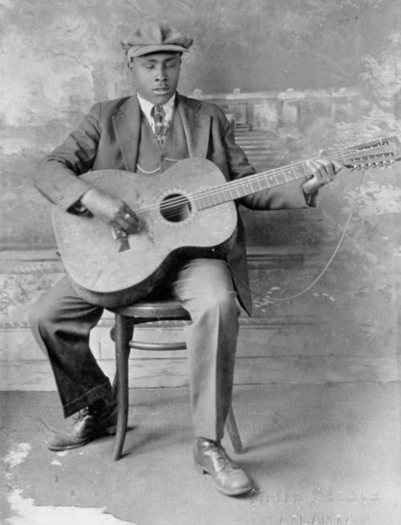

*Blind Willie McTell*

Seen the arrow on the doorpost  
Saying, "This land is condemned  
All the way from New Orleans  
To Jerusalem."  
I traveled through East Texas  
Where many martyrs fell  
And I know no one can sing the blues  
Like Blind Willie McTell

Well, I heard the hoot owl singing  
As they were taking down the tents  
The stars above the barren trees  
Were his only audience  
Them charcoal gypsy maidens  
Can strut their feathers well  
But nobody can sing the blues  
Like Blind Willie McTell

See them big plantations burning  
Hear the cracking of the whips  
Smell that sweet magnolia blooming  
(And) see the ghosts of slavery ships  
I can hear them tribes a-moaning  
(I can) hear the undertaker's bell  
(Yeah), nobody can sing the blues  
Like Blind Willie McTell

There's a woman by the river  
With some fine young handsome man  
He's dressed up like a squire  
Bootlegged whiskey in his hand  
There's a chain gang on the highway  
I can hear them rebels yell  
And I know no one can sing the blues  
Like Blind Willie McTell

Well, if God is in his heaven  
And we all want what's his  
But power and greed and corruptible seed  
Seem to be all that there is  
I'm gazing out the window  
Of the Saint James Hotel  
And I know no one can sing the blues  
Like Blind Willie McTell

America

Sometimes loved

Sometimes hated

But always imitated



The Day the Music Came to Life Again

Bijlages

Noord Amerika omstreeks 1750

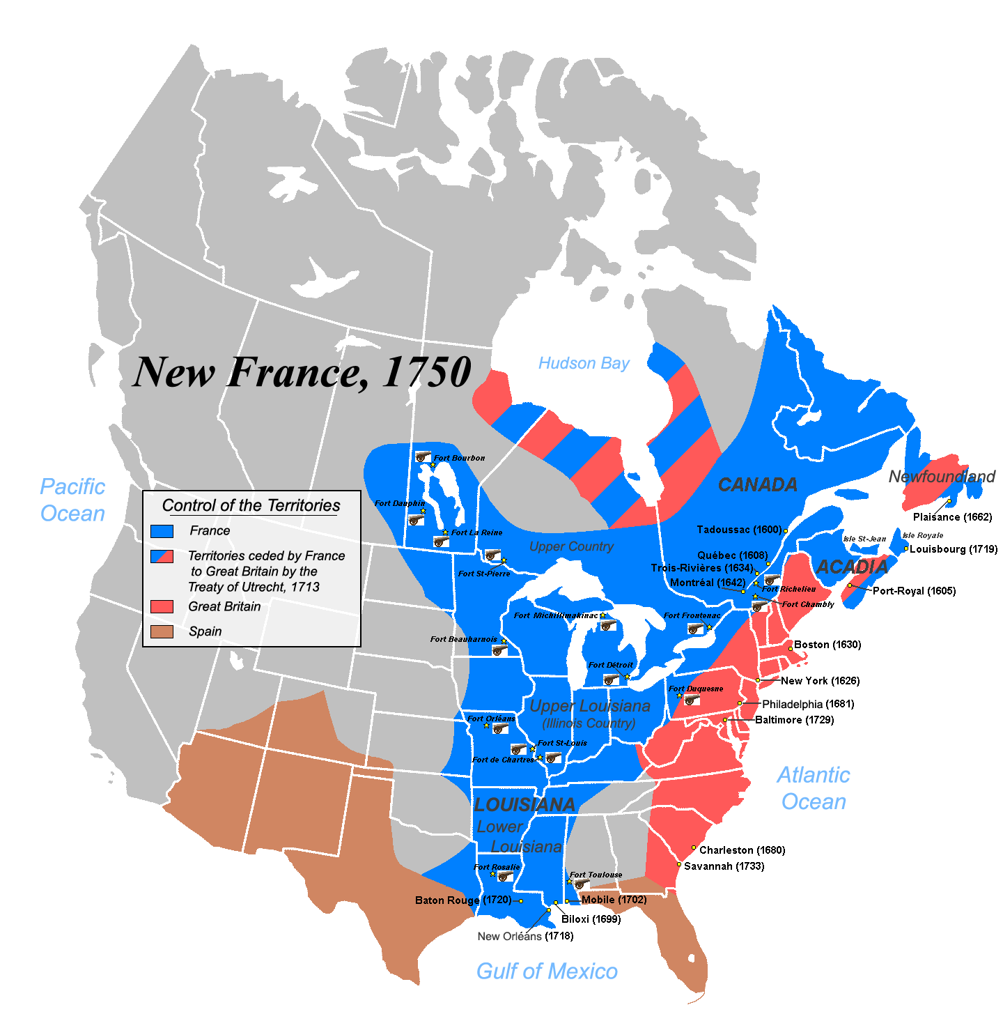

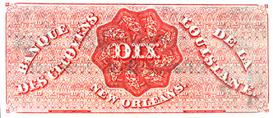

Dix Dollar Bill (Dixie) Louisiana *(oorsprong naam Dixieland)*

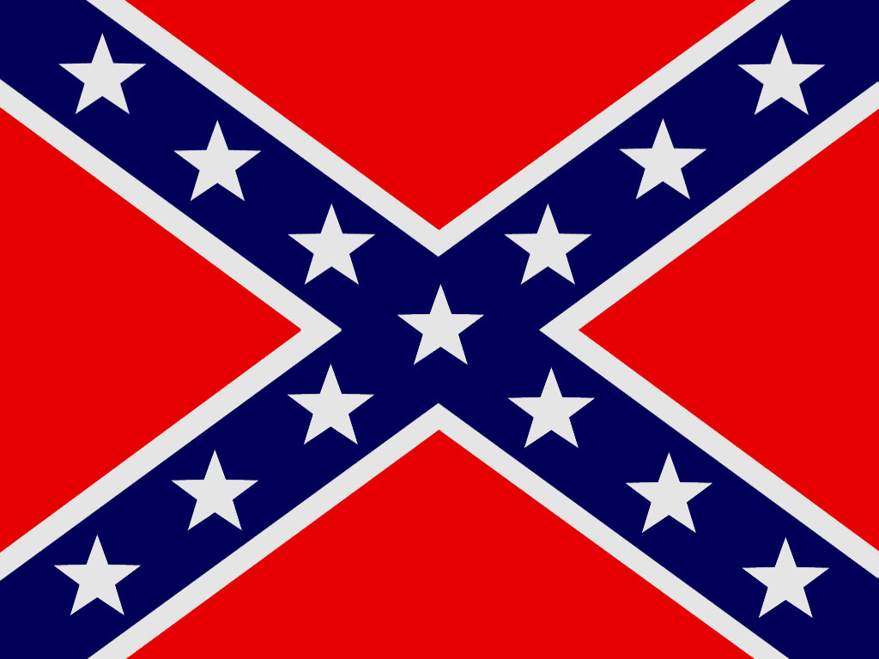

Confederate (Rebel) Flag *(13 Confederation States)*

Wapenschild Mexico (zie legende Mexicas = dominante subgroup v/d. Azteken over ontstaan Tenochtitlan = Mexico stad)

